Ministry Team
Vicar: Rev’d Gary Birchall
Assistant Curate: Rev’d Simon Cocks
Churchwardens: Peter Swaine and Pam Baxter
Readers: Gary Connell, Elaine Riley, Rob Rolfe
Pastoral Team Co-ordinator: Lin Benson
Parish Administrator: Danielle Woolaston
Children’s Work Co-Ordinators: Trudy Walsh, Gail Adams, Jan Peel, Tusheeta David
Safeguarding Officers: Rev’d Gary Birchall/Gail Adams
Sacriston: Kevin Plummer

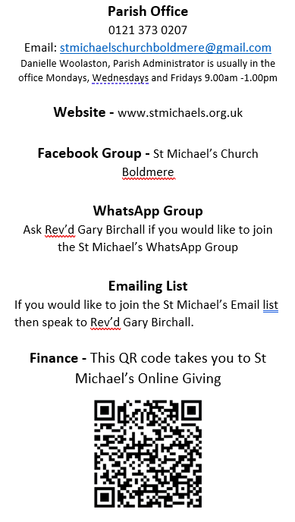
We all need…
A Churchwarden to take over from Peter Swaine when he steps down from the rolel in May this year. You would be working alongside Pam Baxter, Rev’d Gary Birchall, the PCC and the Parish Administrator to oversee the life and running of St Michael’s Church. Is this what God might be calling you to at St Michael’s. Speak to Rev’d Gary, Pete or Pam.
St Michael’s Herald 2024
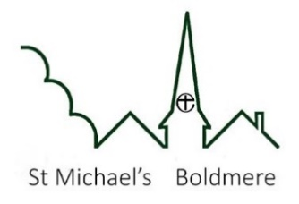
Services in Church

Sunday Mornings 10.00am – usually a Holy Communion Service + groups for different ages.
Usually livestreamed on YouTube

Sunday Evenings 6.00pm – usually a quiet reflective service following a particular theme.

Morning Prayer on Zoom- Wednesdays 10.00am
Meeting ID: 298 679 1058
Passcode: 905710

Friday Holy Communion in Epiphany Chapel at 11.00am as part of Place of Welcome

Celebrate – Jesus at the Centre
A gathering for children and families: 2nd Sunday of each month at 3.30pm – next date: 10th March at 10.00am for Mothering Sunday, 14th April

Sunday Groups
South Aisle Saints – for pre-school children and parents/carers in South Aisle
FLOK – for primary school aged children.
FLOK+ for Year 6 upwards.

Forthcoming Events

An Aston and Sutton Coldfield Deanery welcome service for Right Rev’d Michael Volland, the new Bishop of Birmingham on Sunday 17th March at 7.30pm at St John’s Church Walmley. All of us are welcome (no booking required).

Easter Garden making Saturday 23rd March 10.00am to 12.00noon

Bring and Share Lunch – Sunday 24th March after the morning service.
Beetle Drive – Saturday 13th April 4.30pm to 7.00pm

Christian Aid Big Brekkie: Saturday 11th May in the South Aisle. Enjoy a breakfast and support the work of Christian Aid. Put it in your diary.

Church Picnic – Sunday 2nd June to mark the 10th anniversary of Rev’d Gary Birchall being Vicar at St Michael’s

Looking Ahead – Sunday Services

Sun 3rd Mar – 10.00am Holy Communion
6.00pm – I Am sayings of Jesus Evening Service

Sun 10th Mar – Celebrate at 10.00am
6.00pm – Holy Communion, I Am sayings of Jesus

Sun 17th Mar – 10.00am Holy Communion
6.00pm – I Am sayings of Jesus evening service

Sun 24th Mar – Palm Sunday 10.00am Holy Communion with a dramatic reading of the Passion according to Mark
6.00pm – Stations of the Cross

Monday to Wednesday in Holy Week – 7.30pm to 8.00pm The Jesus Prayer at the Cross in the Epiphany Chapel

Maundy Thursday 28th March – 7.30pm Tennebrae Service

Good Friday 29th March – 10.00am Good Friday Service shared with Chester Road Baptist Church at Chester Road Baptist Church.

12.00noon to 3.00pm – Reflections on the Passion according to Mark.

Easter Sunday 31st March -
6.00am Easter Dawn Service
10.00am Easter Day Holy Communion

Regular Weekly/Monthly Activities:

Men’s Night – first Tuesday of each month in the Bishop Vesey pub from 7.30pm

Place of Welcome – Fridays in the South Aisle in St Michael’ Church from 10.00am to 12.00noon now including Crafting in Company and 11.00am Holy Communion.
Music and Singing Team – 6.00pm to 7.00pm most Fridays in the Church. Speak to Rev’d Gary Birchall if you would like to get involved.

March Tips

Everyday Faith: if someone says “sorry”, pause … and make it clear that you accept their apology.

A Rocha Eco Church: Celebrate Spring. Immerse yourself in the sights and sounds of the season –Nature can boost our happiness, so spend time in your garden, on your balcony, and in local green spaces. Dedicate quality time to appreciate creation’s beauty, and thank God for the hope that spring can bring with our Lent resources at arocha.org.uk/ connect-with-gods-creation-overlent
Building Update
The building group are working hard on considering draft designs and costings from the Architect. Please pray for wisdom for this process.

Focus on Welcome
Elaine Riley has been preparing Story bags for children which can be found at the back of the church. First four feature Creation, Noah, Daniel and Teddy Bear. Take a look.

